**PHASE 1 – ENCRYPTION/DECRYPTION**

**1. Scenario & Scope:**

A company hired me to create a Human Resources management application as their department are getting bottle-necked by all of the paperwork that needs to be done. They need a simple solution to store information about their employees and have the employees report concerns and general information via a separate form. This information is sensitive and needs the required security(encryption) and proper user account management.

**Solution:**

I will be building one application that can be hosted on an employee’s kiosk for the employees to log into their account and report their concerns and activities such as sick leave or vacations. The HR department can also then log into their account to view this information and the system will automatically generate reports. All information will be stored in a database and reports can be exported to text files.

**Scope:** Use a database to store user credentials, use encryption to store sensitive information

**2. User Requirements:**

|  |  |  |  |
| --- | --- | --- | --- |
| **Users** | **Role (Group)** | **Activities** | **Limitations** |
| Admin | Administrators | Manage Database | None |
| Member of HR department | HRdep | View reports add/remove users | Manage everything except Administrators |
| General users | Employees | Report activities and concerns | Add/Remove users  View sensitive info |

**3. Navigation/Description of Flow Diagram:**

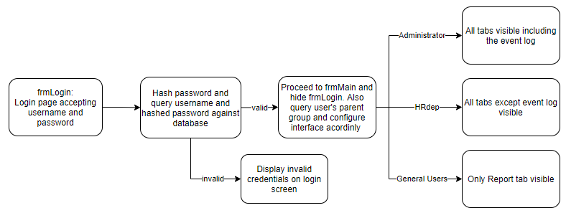

**4. Data Structures:**

- Database:

- Text file(s):

- Array(s): Will be used for the password hashing, encryption and decryption functions.

**5. GUI design:**

**6. IPO:**